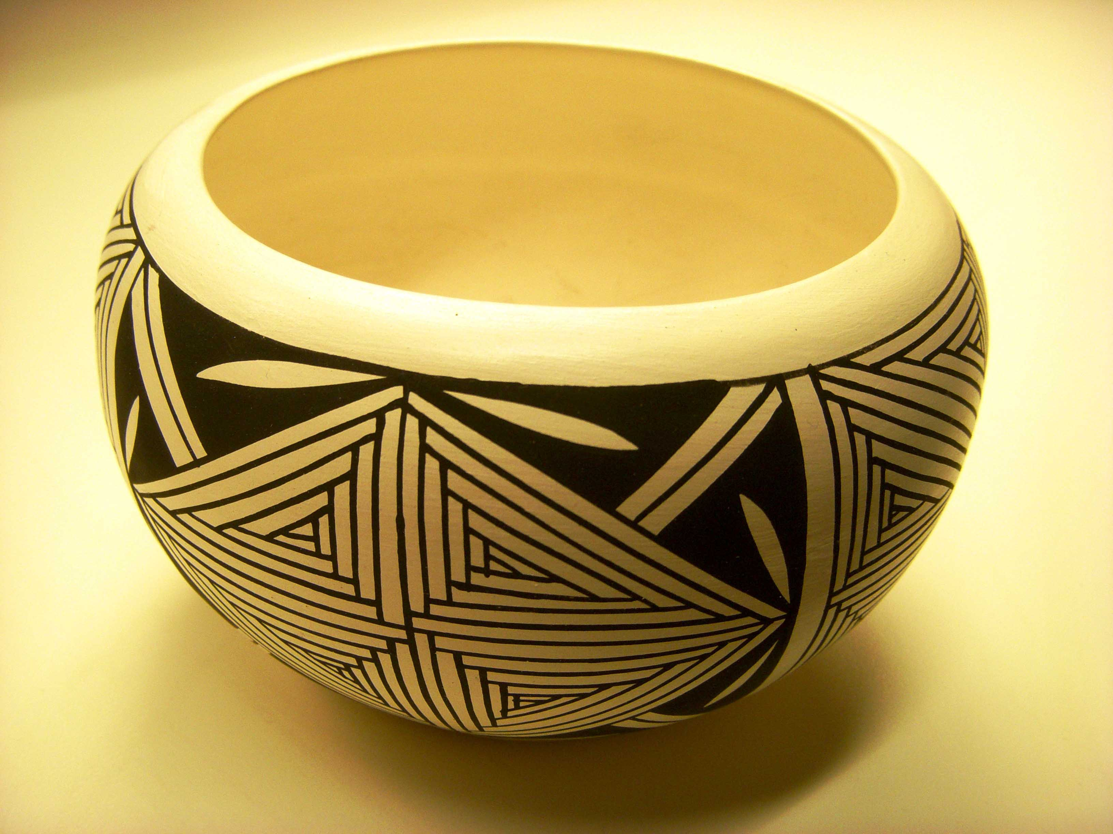
Tell Us What’s Going On in Your Area
Indian Affairs needs input from you!
Are you in contact with any Native Americans in your monthly meeting geographical area?
How can we as individuals begin or strengthen these connections?
Can we try reaching out and meeting with people on an individual level? Do you think perhaps a dialogue can be started?
We wish to hear from Friends who would like to share their ideas on what is working or not working for their monthly meeting, so we can all encourage and learn from each other.
What are Friends’ concerns today related to Native American affairs?
We are especially interested in supporting members and attenders who are involved with their own meeting, but are not necessarily involved in Yearly Meeting activities.

We would appreciate your help in having your meeting complete our recently e-mailed brief questionnaire.
Please e-mail it back to Sue Wolf at quakerwolf@gmail.com.
Or you can mail it to Sue Wolf at 217 Rachel Carson Way, Ithaca, NY 14850
Phone: (607) 272-1618
You may also contact Sybil Perry, coclerk of Indian Affairs, by e-mail at sybilmperry6@att.net or by Phone: (860) 672-1434.

We welcome any thoughts, questions and sharings.
Thank you all.

